**TAMPERE UNIVERSITY**

**DEE-53117 Solar Power Systems**

**PRACTICAL WORK: OPERATION OF PV POWER GENERATORS**

**Simulation and Analyses - Report**

|  |  |
| --- | --- |
| **Name** | **ID** |
| Sayad Mohammad Mahadi Hassan | 281750 |

Date:16-April-2019

1. **Operation of PV modules**

**1.1 Study how ideality factor *A* and parasitic resistances *R*s and *R*sh affect the current–voltage characteristics of a PV module. (Initial values: *A* = 1.3, *R*s = 0.33 Ω, *R*sh = 188 Ω)**

**Use the initial values for *R*s and *R*sh and modify *A:***

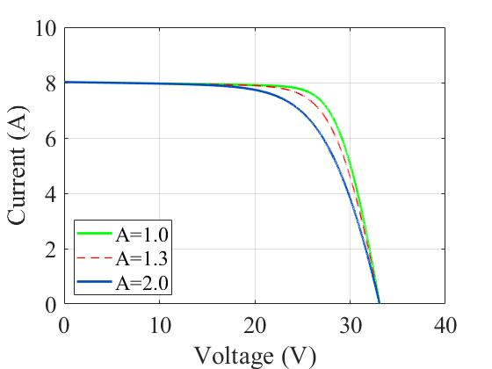

Fig-1: Current-voltage curves with varying ideality factor (A).

The ideality factor (A) is a measurement of a solar cell junction quality and type of recombination in a solar cell. The junction quality means how closely the diode follows the ideal diode equation. The Fig-1 is shown the current-voltage curve with different ideality factor of solar cell. From the figure we can say that an increase in ideality factor lower the fill factor (FF) of a solar cell, which is the measurement of a solar cell maximum power.

The FF is the ratio of the maximum power and the product of open circuit voltage, Voc and Short circuit current, Isc.

Moreover, the decrease of FF is also the decrease of solar cell efficiency and the efficiency is defined as:

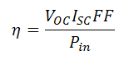

Therefore, from the graph we can see that with the increasing value of “A”, value of current which in term means MPP reduces.

**Use the initial values for *A* and *R*sh and modify *R*s:**

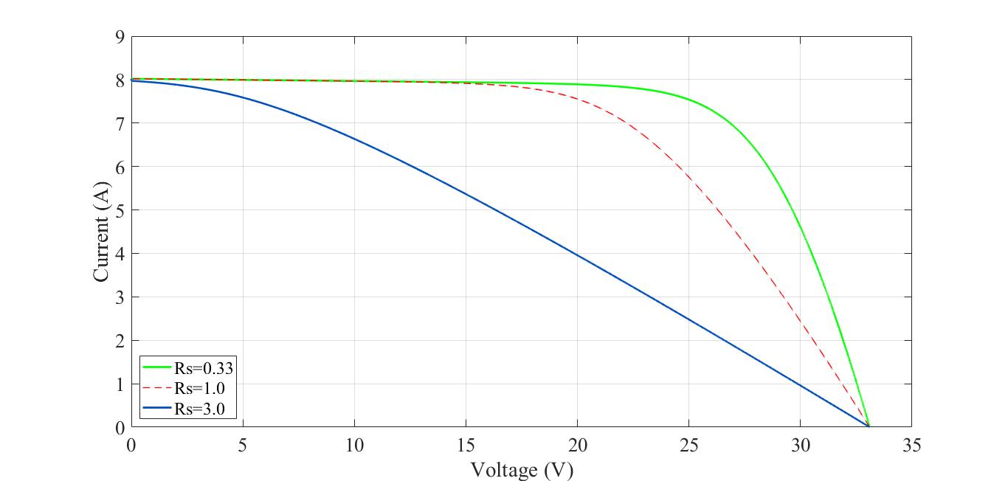

Fig-2: Current-voltage curves with varying series resistance (RS)

From the Fig-2, it is shown that the series resistances (RS) of a solar cell increase the fill factor (FF) losses. For the same increased current, the impedance to the voltage drop between the junction voltage and the terminal voltage becomes greater; therefore, the IV curve begins sag towards the root point, which results a significant drop in voltage in the terminal. As we can see in the Fig-2, for the series resistance 0.33, the voltage was 25V at the point of MPP but it decreased to 20V when the Rs used 1.0 and the effect is very clearly visible for high series resistance 3.0. Also, for the very high series resistance will produce a significant reduction in Short circuit current as well.

**Use the initial values for *A* and *R*s and modify *R*sh:**

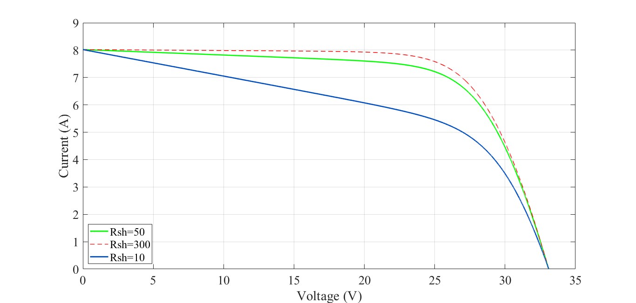

Fig-3: Current-voltage curves with varying shunt resistance (RSh)

The power losses, due to low shunt resistance of solar cells are caused by the presence of shunt resistance by providing an alternate current path for the generated current. That is the reason for flowing the reduced current amount through the cell. From the fig-3, it is shown that due to the high shunt resistance value 300 the current amount was approximately 8A but the amount decreased significantly to around 6A when the shunt resistance used very low, in our case 10. As the shunt resistance decreasing, there is significant decrease in the terminal current as higher current passes through the low shunt resistance path.

The effect of the shunt resistor is particularly high under low light, as low light produces low amount of current. Moreover, the influence of the parallel resistance is also high at a lower voltage at which the effective resistance of the solar cell is high.

* 1. **Study how operating conditions (irradiance and temperature) affect the current–voltage characteristics. Use the initial parameter values (A = 1.3, Rs = 0.33 Ω, Rsh = 188 Ω).**

**Keep the irradiance constant and modify the operating temperature:**

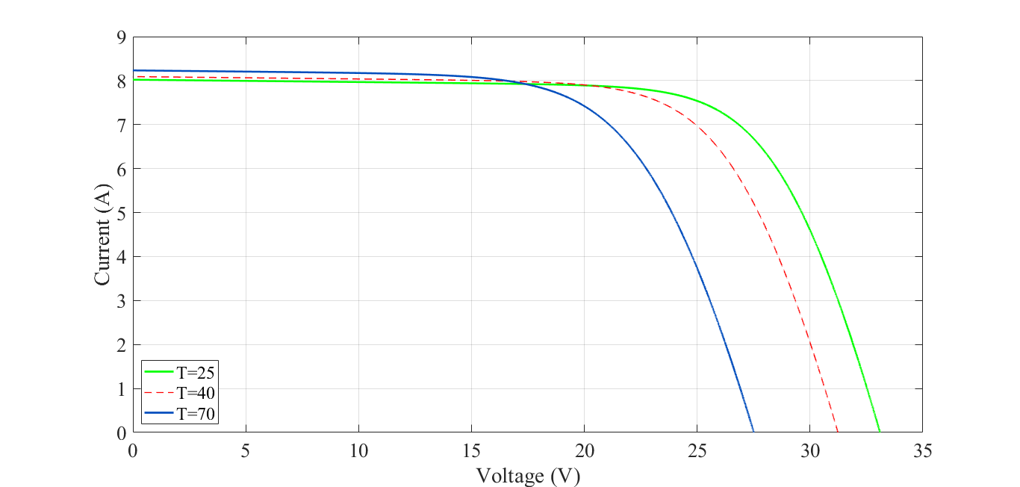

Fig-4: Current-voltage curves with varying Operating temperature (T)

Solar cells are made of temperature sensitive semiconductor material. That means the band gap of a semiconductor reduces as increases in temperature. Semiconductor parameters that are most affected by temperature increases reduce the open circuit voltage (Voc) in solar cells. This level of decline is inversely proportional to VOC; higher VOC means that a high quality cell can reduce voltage in smaller amount as temperature increases. From Fig-4, it is shown that with the increasing temperature the short circuit current increases slightly but a considerable decrease in VOC also happened as well.

**Keep the operating temperature constant and modify the irradiance:**

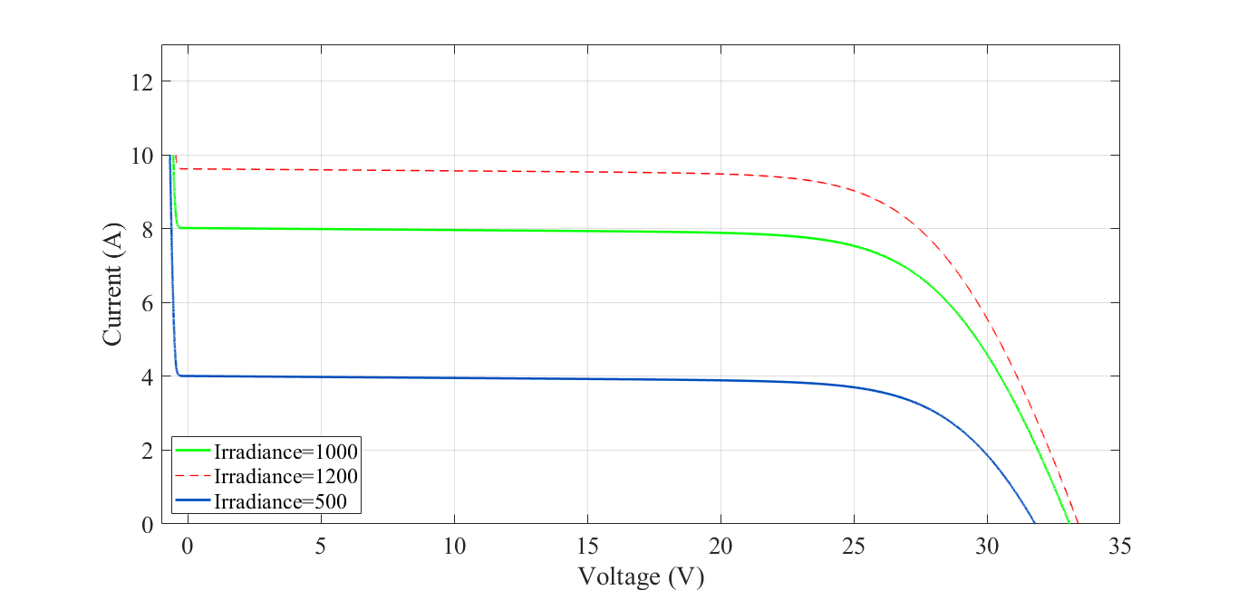

Fig-5: Current-voltage curves with varying irradiance

All parameters of the solar cell, open circuit voltage, FF, series and shunt resistance and including short circuit current are affected by changes in the response of the solar cell to the irradiance. The open circuit voltage depends on the short circuit current and, therefore, slightly increases due to irradiance reduction. According to the Fig-5, with the increase of irradiance value, short circuit current increases as well as slight increase in Voc which in terms increase the MPP.

1. **Operation of series-connected PV modules under partial shading**

**2.1 Study how power–voltage characteristics change when the number of shaded modules increases.**

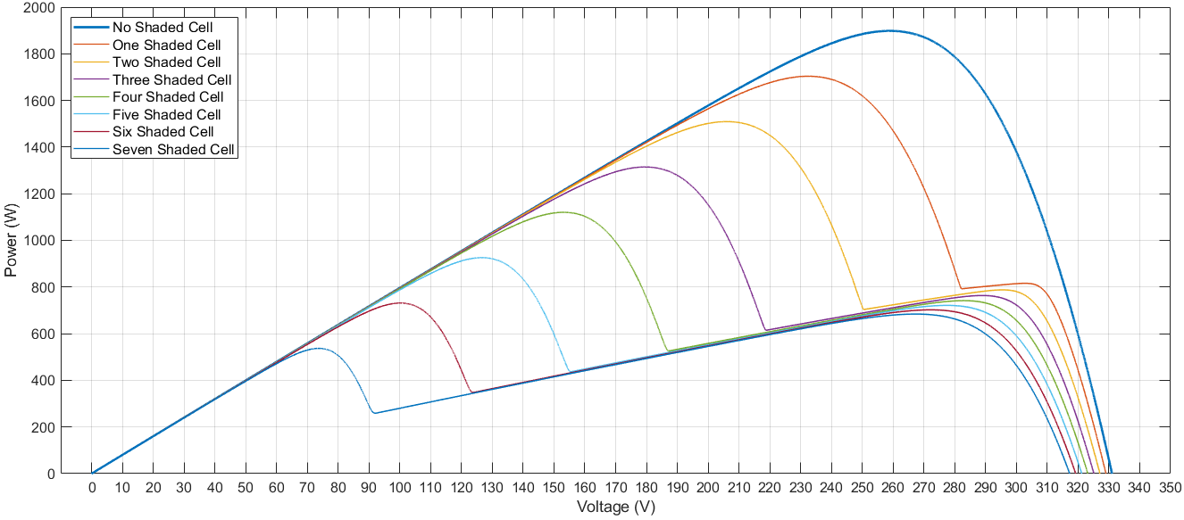

Fig-6: Power-Voltage curve when number of shaded module increases

As the number of shaded cells increases in series, the losses in cells are increases and the output power decreases. With the flow of current through each cell in the series, the configuration is inherently constant and the shaded cell should work with a reverse bias to deliver the same current. But, As a result, the reverse polarity leads to power consumption and reduces the maximum energy output of the partial shaded photovoltaic modules. Also, shaded cell excessive reverse bias exposure can cause "hot spot" and create an open circuit in the entire PV module. Interruption via the solar cell module is often resolved the bypass diodes in the Series circuit. Since the bypass diodes provide an alternate current path, during partially shaded situation the cells of a module no longer carry the same current.

Thus, the power-voltage curve shows several maximum points, but the highest power point will become global maximum power point.

With no shaded cells, there is only one MPP and for others there are two MPPs, one of which is Global MPP and other is local MPP.

Voltage of global MPPs are:

|  |  |  |  |  |  |  |  |
| --- | --- | --- | --- | --- | --- | --- | --- |
| No shaded cell | One shaded cell | Two shaded cell | Three shaded cell | Four shaded cell | Five shaded cell | Six shaded cell | Seven shaded cell |
| 260V | 230V | 210V | 180V | 150V | 125V | 100V | 75V |

From the table it can also be seen that with increasing number of shaded cells, MPP voltage reduces.

**2.2 Next, study situations where there are three values of irradiance affecting the generator.**

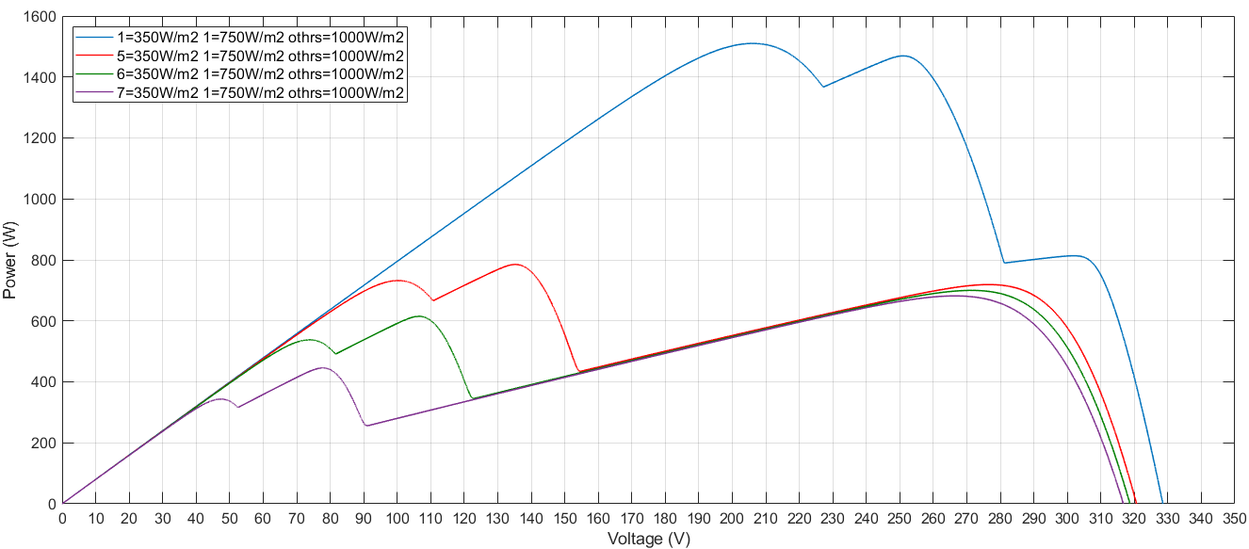

Fig-7: Power-Voltage curve for three values of irradiance affecting the generator

Each solar cell is connected by a parallel bypass diode but connected to the opposite pole. In normal operation, the bypass diode connected in reverse, so the solar cell tilts forward when the circuit is open circuit. When one of the series connected PV cell is shaded the entire connection is become reverse biased. In this case the shaded cell can consume part of or all of the generated power by other cells and can be damaged which known as “Hotspot”. If the reverse polarity is higher than the voltage of the knee of the solar cell, the diode is turned on and the current is passed. The number of MPP quantity modules depends on the number of bypass diodes.

For three shaded condition values of irradiance (350 W/m2, 700 W/m2, 1000 W/m2) with individual bypass diode, there are three MPP points in every case.

Voltage of the global MPPs are:

|  |  |  |  |
| --- | --- | --- | --- |
| 1Mod=350W/m2,  1Mod=700W/m2,  Others 1000W/m2 | 5Mod=350W/m2,  1Mod=700W/m2,  Others 1000W/m2 | 6Mod=350W/m2,  1Mod=700W/m2,  Others 1000W/m2 | 7Mod=350W/m2,  1Mod=700W/m2,  Others 1000W/m2 |
| 205V | 100V | 75V | 45V |

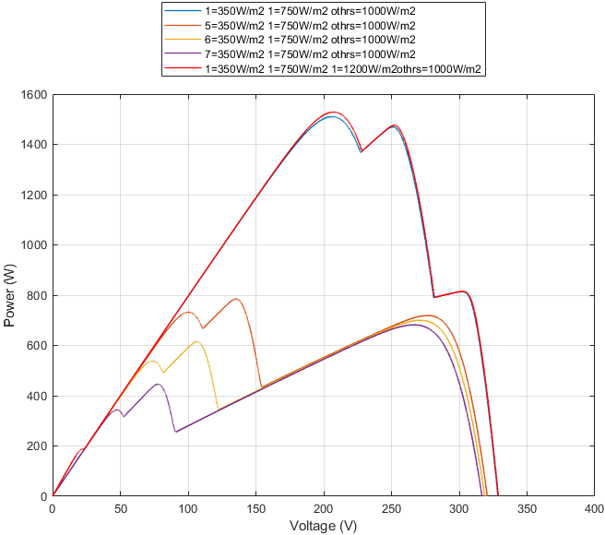

Fig-8(a): Three values of irradiance

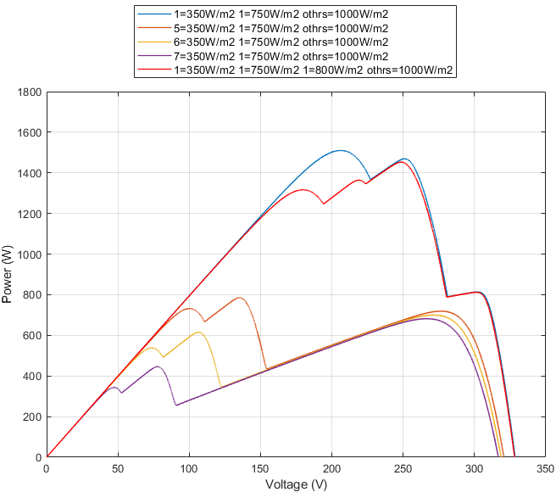

Fig-8(b): Four values of irradiance

To understand more about the number of MPPs on bypass diode dependency we simulation two more conditions, one is with 1Mod=350W/m2, 1Mod=700W/m2, 1Mod=1200W/m2 Others 1000W/m2 and another one is with 1Mod=350W/m2, 1Mod=700W/m2, 1Mod=800W/m2 others 1000W/m2.

From Fig-8(a), it is shown that if the new irradiance value is more than standard value, in our case 1200W/m2, there will be no change is number of MPPs because of forward bias operation. From Fig-8(b), it is shown that if the new irradiance value is less than standard value, in our case 800W/m2, the reverse bias operation activated and we have found one more MPP.

So we can say that for each of series connected PV module become shaded, bypass diode gets activated and number of MPP increases at the same rate of shaded module.

1. **Operation of Perturb and Observe (PO) MPPT algorithm**

**3.1 Perturbation frequency and perturbation step size**

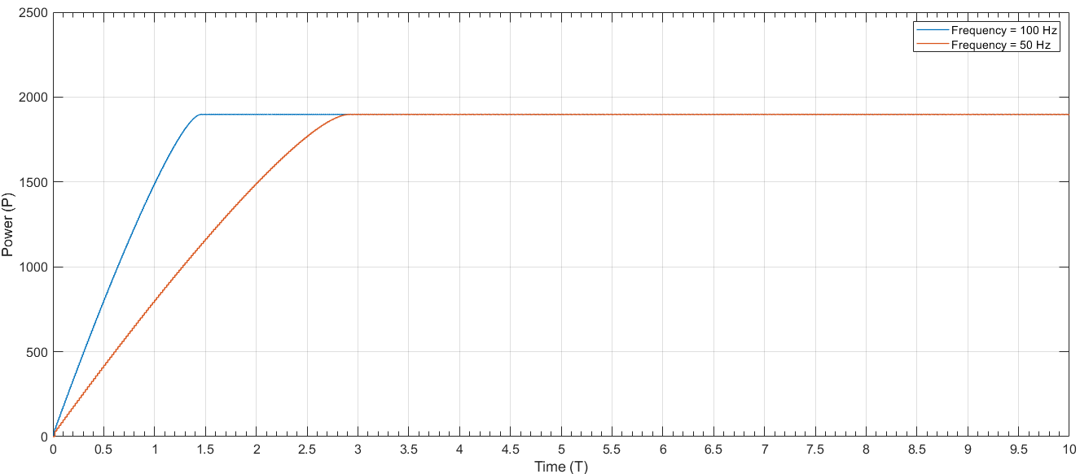

Fig-9: Effect of perturbation frequency on the time to reach MPP

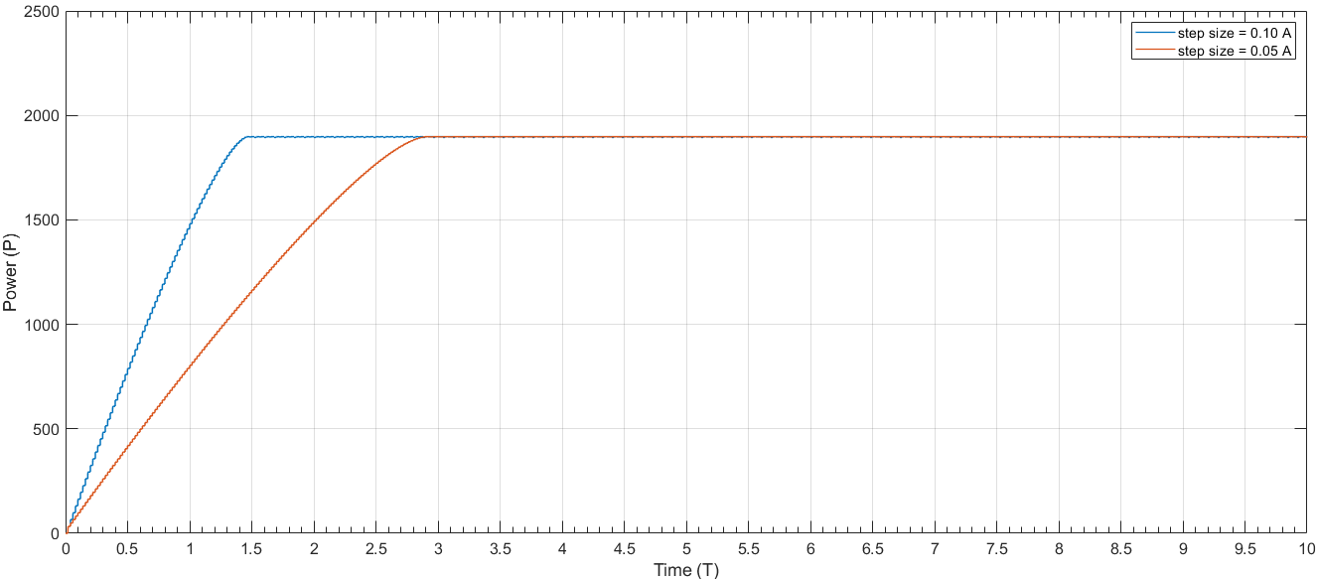

Fig-10: Effect of perturbation step size on the time to reach MPP

The main reason for various energy efficiency values is the choice of P&O algorithm parameters, such as the size and frequency of the perturbation.

According to the graph, for increasing the perturbation step size and perturbation frequency, less time required to reach the MPP. In order to reduce the oscillation of the MPP, however, it is necessary to carefully choose the perturbation step size and perturbation frequency depending.

However, to reach the MPP in less time the perturbation step size is more effective than the perturbation frequency. Fast tracking can be achieved with big step sizes but cause high oscillation. A smaller value reduces the steady-state loss caused by the oscillation of the operating point PV near the MPP, but gradually the efficiency of the algorithm becomes lower for the fastest changing in irradiance conditions.

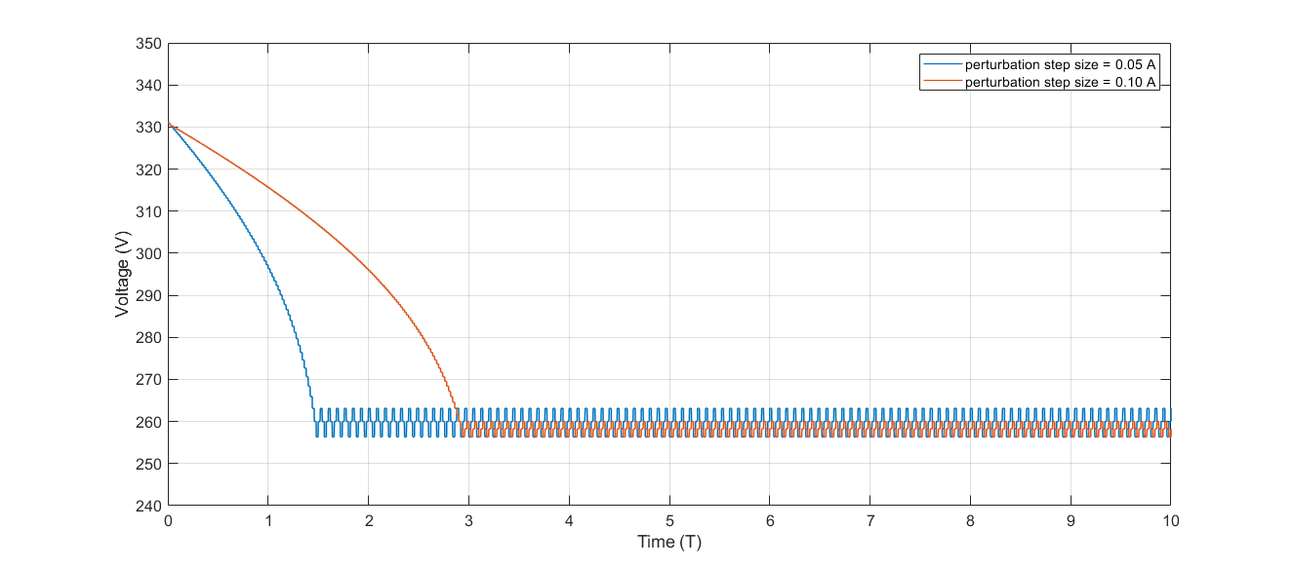

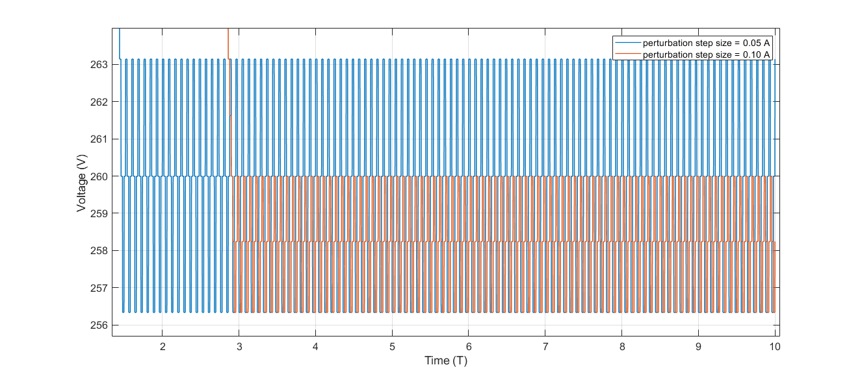

Fig-11: Voltage of the generator when operating at MPP at varying perturbation step size (below ZOOMED)

From the Fig-11, it is shown that at low perturbation step size less oscillation happens where as higher oscillation causes for high step size.

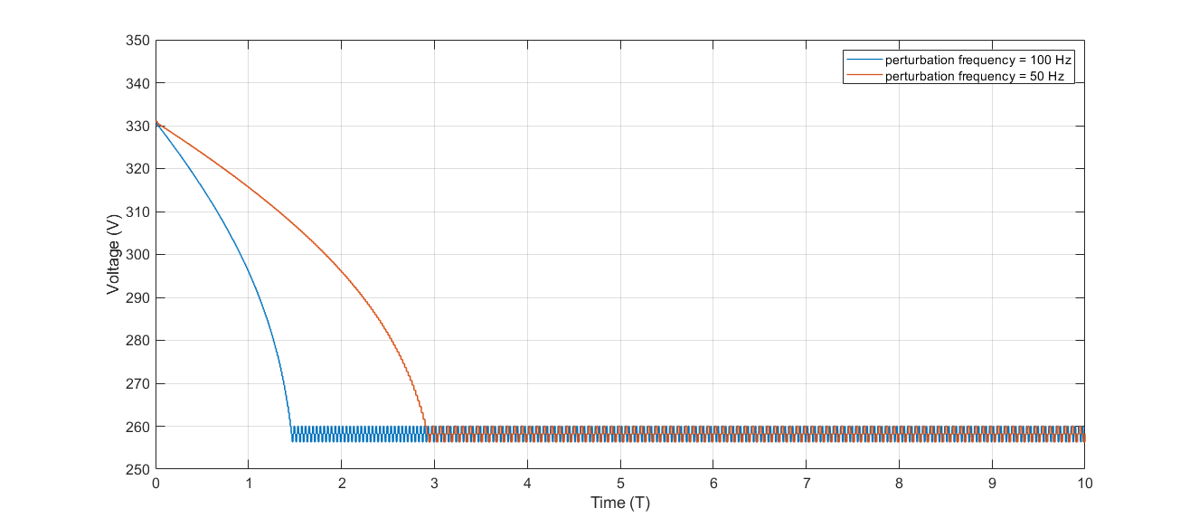

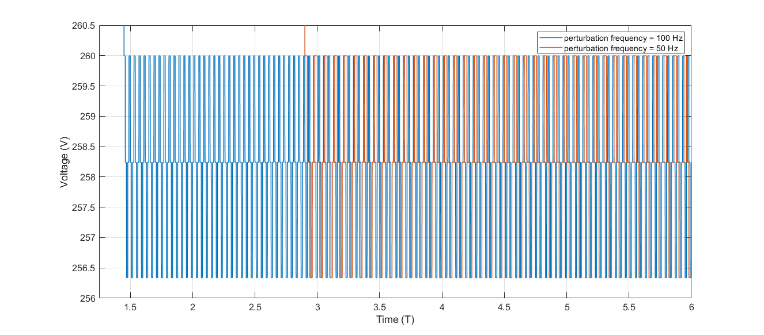

Fig-12: Voltage of the generator when operating at MPP at varying perturbation frequency (below ZOOMED)

From the Fig-12, it is shown that a higher perturbation frequency results in faster deviation from the MPP, faster recovery, and a faster response to irradiance and temperature changes. If the perturbation period becomes lower than the settling time of the system, the system is never allowed to reach a steady state.

**3.2 Perturbation frequency=50 Hz and the perturbation step size=0.05 A & Switch 2 ON**

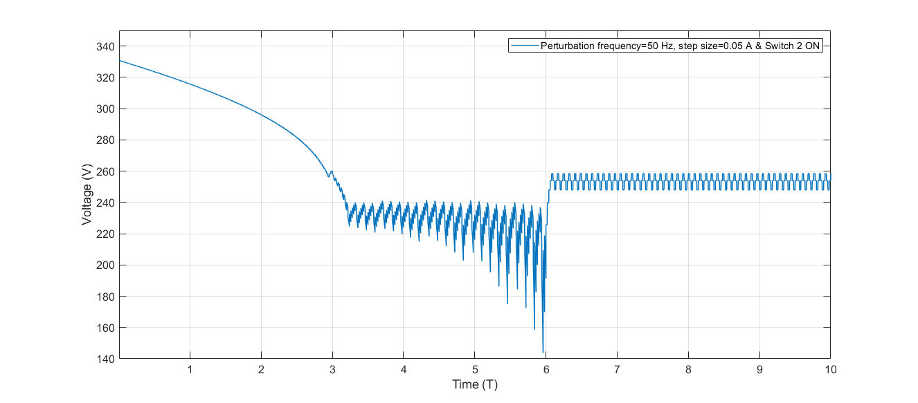

Fig-13: Operating voltage as a function of time

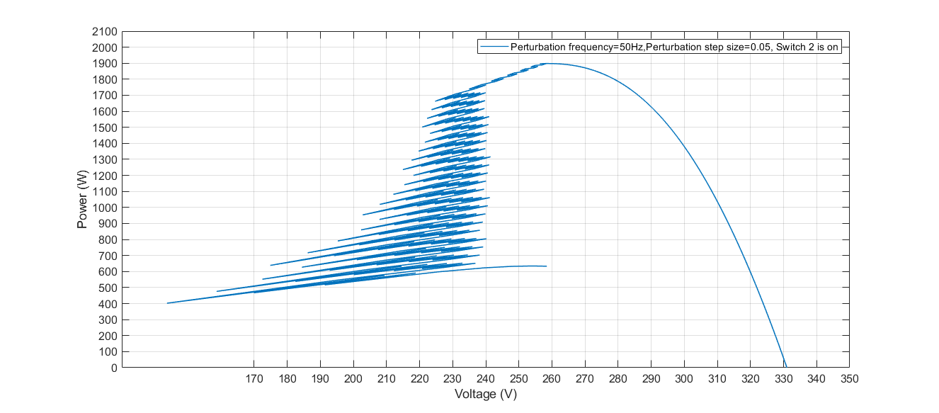

Fig-14: Power-Voltage curve with changing irradiance conditions

Maximum voltage point changes are closely related to irradiance and maximum current point is proportional to irradiance. From the Fig-13, it is shown that with changing irradiance value ramping down, MPPT changes a lot, tries to track the maximum power and when the irradiance become stable at 350w/m2 MPP obtained. From the power-voltage curve, Fig-14 it is shown that, MPPT changes as irradiance changes and obtained 260V MPP.

**3.3. Irradiance of 5 PV modules to be constant at 1000 W/m2 and Switch 3 ON and  
decreases linearly during the next (a) 3 seconds and (b) 1.5 seconds:**

**Fixed irradiance for 5 PV modules and varying irradiance for 5 PV modules for 3 s and 1.5s**

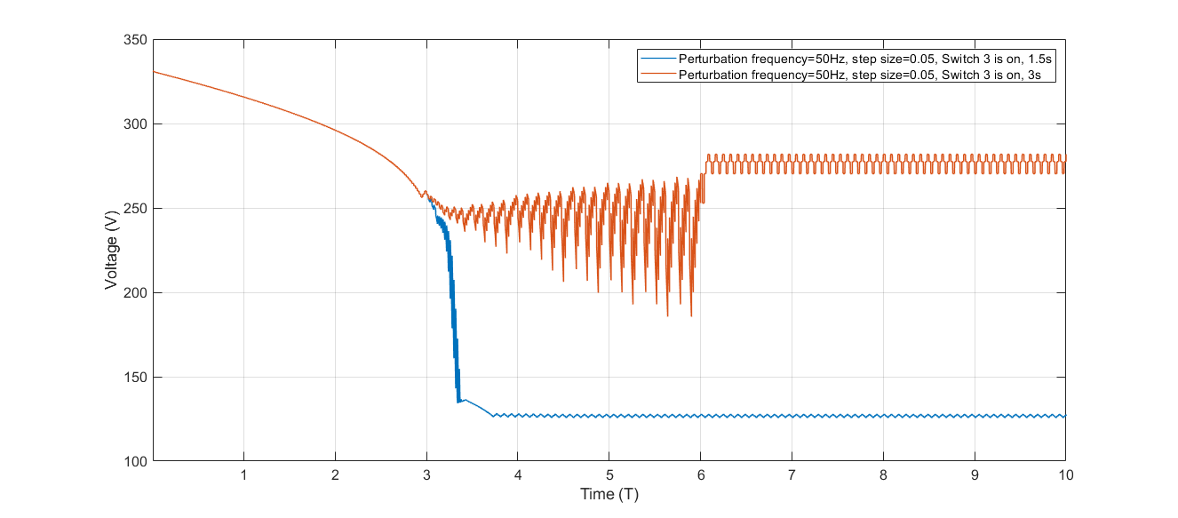

Fig-15: Operating voltage as a function of time

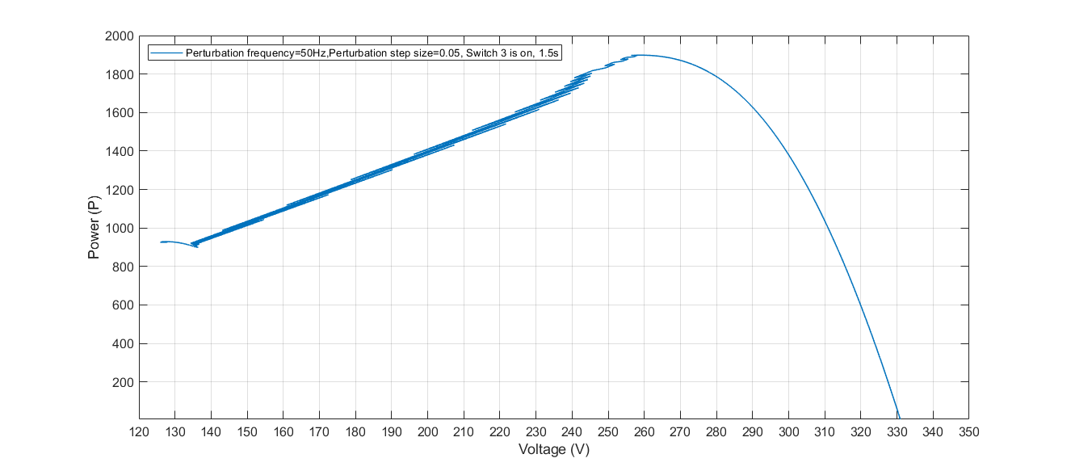

Fig-16: PV curve for decreasing linearly within 2 seconds from 1000W/m2to 350W/m2

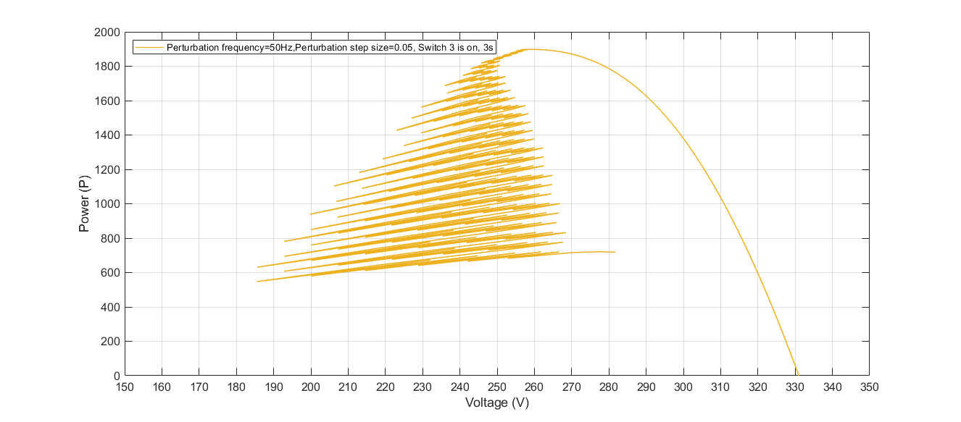

Fig-17: PV curve for decreasing linearly within 3 seconds from 1000W/m2to 300W/m

From the above figures (Fig-15, 16, 17) it is shown that, for irradiance changes in 1.5 seconds the MPPT failed to obtain the correct value and operating voltage is perturbed in opposite direction, so the MPP is local about 130V which is not the global MPP. One the other side, for the irradiance changes in 3 seconds the MPPT obtained the correct value about 260V. Rapid change of irradiance from 1000W/m2 to 350W/m2 within 3s makes P&O to be failed to obtain global MPP.

Low-cost implementations, one of the strength of P&O algorithm, MPP is tracked  
regardless of the irradiance level, temperature, and degradation, ensuring high  
robustness and reliability.

1. **Thermal behavior of PV modules**

**Measured (T19) and Simulated (Tmod_sim) module temperatures:**

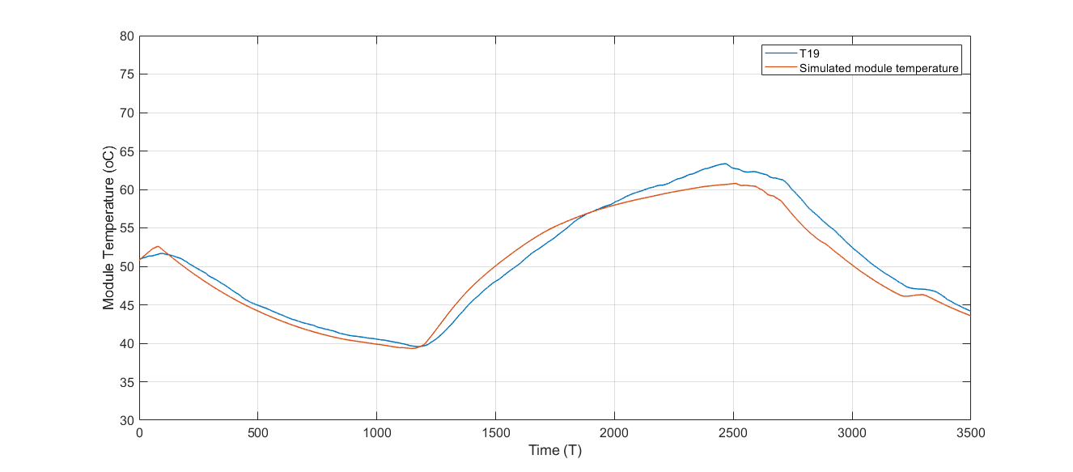

Fig-17: Measured and simulated module temperature vs time

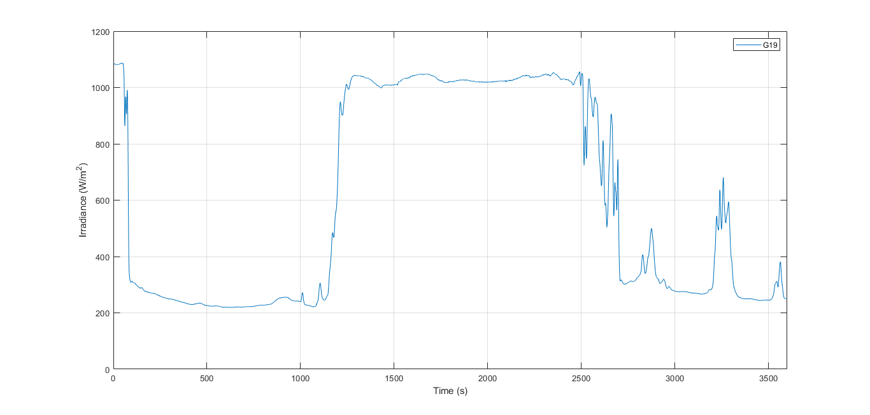

Fig-18: Change of irradiance over time

From the Fig-17 and 18, it is shown that when irradiance is decreasing the simulated module temperature is decreasing as well and vice versa.

This error may be happens when not taking care about environmental effect in the measured temperature. In addition, the simulation condition is based on the standard weather condition which may not be same as actual.

**Ambient temperature:**

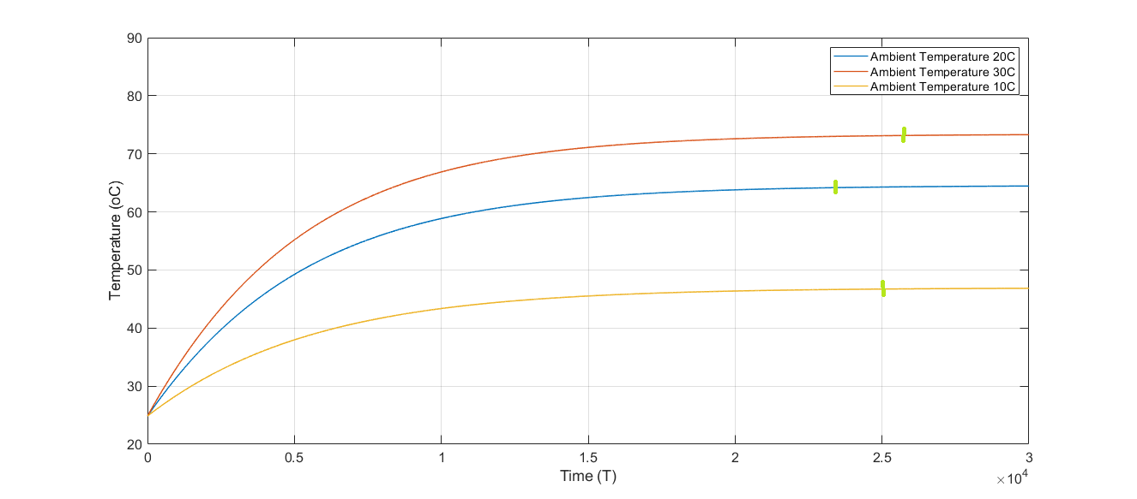

Fig-19: Ambient temperature effect on PV module temperature response

The green markings are the Measured settling times, Fig-19, for three different values of ambient temperature.

The solar modules work best in certain weather conditions but the weather is not same as always, so the PV modules cannot operate in normal operating conditions. During high temperatures the solar panels efficiency decreases. Increase in the ambient temperature value causes the module temperature to increase. From the Fig-19 it is shown that ambient temperature higher or lower is taking more time to become stable. Also, the higher temperature reduces the output power than any other cases.

**Wind speed**

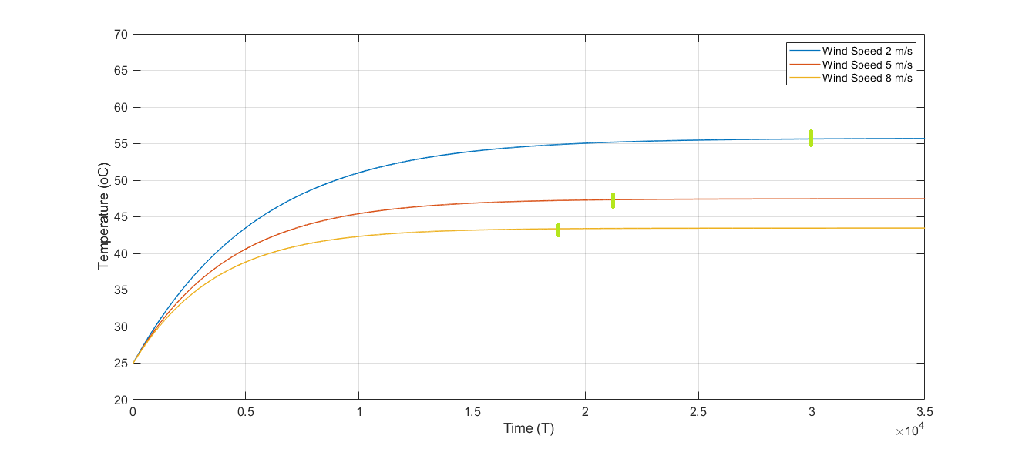

Fig-22: Wind speed effect on PV module temperature response

The green markings are the Measured settling times, Fig-22, for three different values of Wind speed.

From Fig-22 it is shown that for higher wind speeds the PV module temperature responses are decreasing. This is because the air temperatures decrease as the wind speeds increase. Which means the wind can help a solar PV system to produce more output power.

**Heat capacity:**

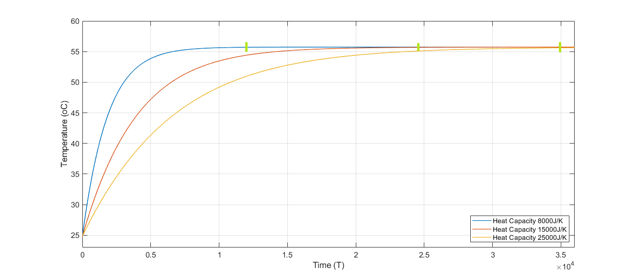

Fig-2*3*: Heat Capacity effect on PV module temperature response

The heat capacity is a measure of the increase in the amount of heat energy. From Fig-23 it is shown that when the heat capacity is reduced, stable time is reduced.

**Irradiance:**

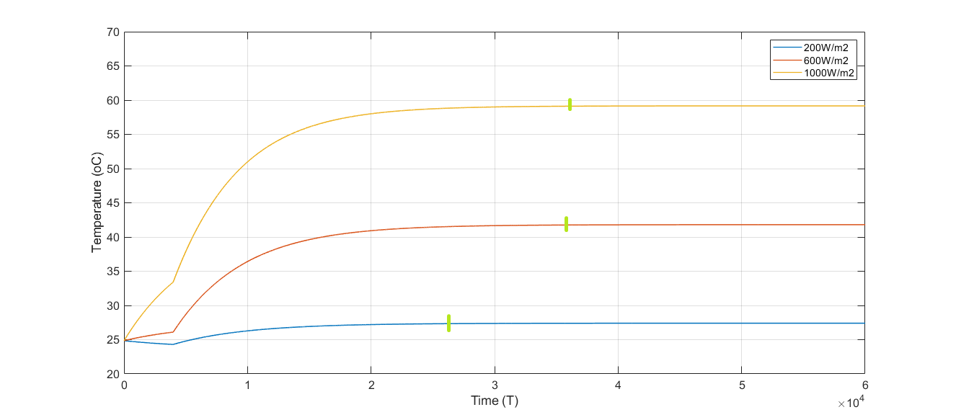

Fig-20: Irradiance effect on PV module temperature response (Irradiance_simulator)

The PV module temperature increases as the irradiance value increases. From Fig-20 it is clearly shown that for all three of conditions temperature responses starts to increase at 400 seconds due to the increase of irradiance values. Moreover, for high irradiance value the module takes more time to become stable.

The green markings are the Measured settling times, Fig-20, for three different values of Irradiance.

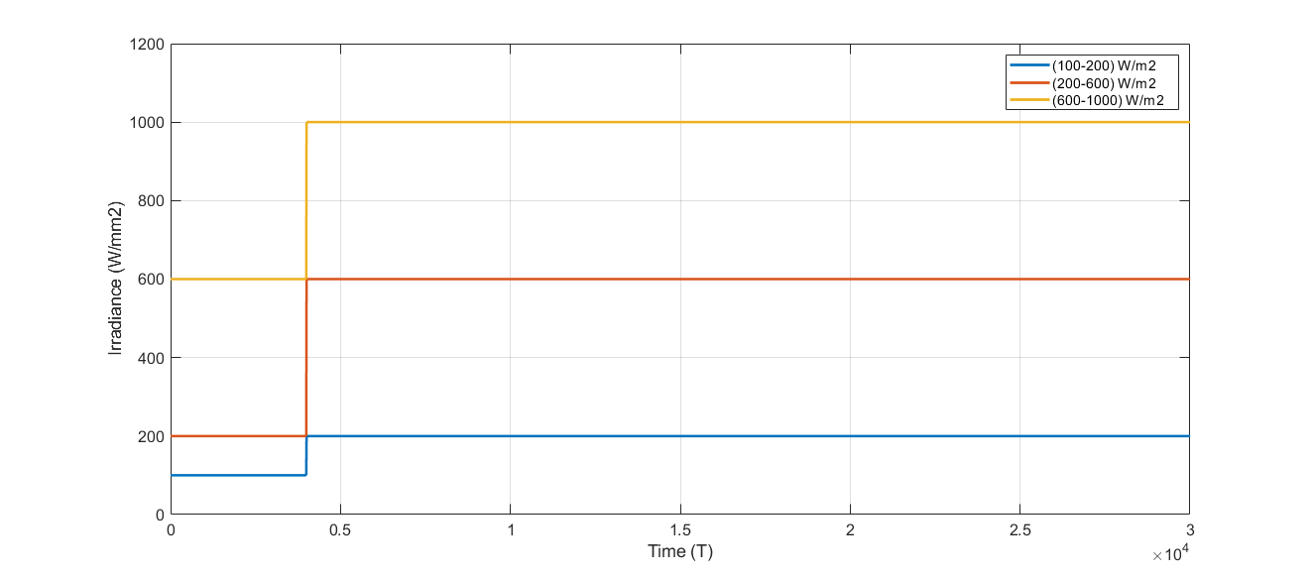

Fig-21: Created irradiance changes

We can see from Fig-21, at 400s, irradiance starts to increase, so does the module temperature and it becomes stable more rapidly according to the value of lower irradiance, Fig-20.

In all continents there are separate weather conditions for solar radiation, there is no specific weather condition which manufacturer can follow to manufacture PV module. So there's a standard test parameters and evaluate all photovoltaic modules in the country / continent's. Under the same conditions, we can have a base of comparison. That’s why the manufacturers provide the electrical performance characteristics of PV modules under Standard Test Conditions (STC) specify an irradiance of 1000 W/m2 and a cell temperature of 25 °C.